ETHlogo

**Lecture with Computer Exercises:**

**Modelling and Simulating Social Systems with MATLAB**

Project Report

|  |
| --- |
| Smart Microgrid with Electric Vehicles |

Xingliang Fang

Seoho Jung

Huiting Zhang

Zürich

11 December 2015

**Agreement for free-download**

We hereby agree to make our source code of this project freely available for download from the web pages of the SOMS chair. Furthermore, we assure that all source code is written by ourselves and is not violating any copyright restrictions.

Zürich, 11 December 2015

Xingliang Fang

Seoho Jung

Huiting Zhang



Smart Microgrid with Electric Vehicles

**Table of Contents**

|  |  |  |
| --- | --- | --- |
| **1**  **2**  **3**  **4**  **5**  **6**  **7**  **8**  **9**  **10** | **Abstract**  **Individual Contributions**  **Introduction and Motivations**  3.1 Background  3.2 Objectives  **Description of the Model**  4.1 EV Agent Model  4.2 Alternative Charging Plans  4.3 EPOS  **Implementation**  5.1 Overview  5.2 Driving Profile Generation with NHTS Travel Data  5.2.1 Extracting Useful Data from NHTS Database  5.2.2 Generating Speed Profile of EVs  5.2.3 Generating Location Profile of EVs  5.3 State of Charge (SOC)  5.3.1 SOC with Regular Charging Plan  5.3.2 SOC with Alternative Charging Plans  5.4 Power Consumption  5.5 EPOS  **Results and Discussion**  **Summary and Outlook**  **Acknowledgements**  **References**  **Appendix** | 5  6  7  9  14 |

**1 Abstract**

**2 Individual Contributions**

**3 Introduction and Motivations**

**3.1 Background**

In an electrical grid system, power generation and consumption should be balanced at all times because an imbalance between them may lead to problems such as voltage fluctuation and power outage. Therefore, a grid system has been designed to have generation capacity greater than the maximum peak demand, which occurs no more than a few times a year.[1] The costs of meeting the peak demand have been significant as generators, transmission lines, circuit breakers, and transformers have been largely underutilized during off-peak hours.[2] The daily peak demand usually occurs around 5:30 PM, due to office use, domestic demand, and, in certain seasons, the fall of darkness.[3]

Our study first started with a conjecture that, along with the already existing factors mentioned above, simultaneous charging of electric vehicles(EVs) during evening hours would further raise the daily peak load. Although EVs only comprise a small portion of the automotive market at the moment, the sales of EVs have surpassed a million since their mass market began only five years ago.[4] Thus, we supposed that, in near future, our grid system will have to either increase its generation capacity or efficiently alleviate the peak demand in order to supply enough power required to charge hundreds of thousands of EVs everyday. The first option seems less ideal because it will lead to even more severe underutilization of facilities. The second option—alleviating the peak demand—secures higher grid robustness, the ability of a network to withstand an unexpected event without degradation in performance.[5] In a grid system that supports electric vehicles, a lower peak load induced by EVs directly leads to greater capacity to serve other unexpected demands. Efficient demand management can be achieved in a few different ways.

A smart microgrid, a modern and localized network, has been considered one possible solution because of its active decentralized management of demand. Unlike a traditional, centralized grid (macrogrid), a microgrid actively responds to locally collected demand information. Therefore, in this study, we have modeled a smart microgrid with EVs, which collects local power consumption information and determines when each of its member EVs should be charged.

**3.1 Objectives**

This study uses a mathematical model and simulation to analyze a smart microgrid with EVs. Our study addresses the following questions:

* How does the total power consumption of a smart microgrid change throughout a day? When does the peak demand occur?
* How and how much can this peak demand be alleviated?
* How and how much does the microgrid save total cost?
* How does the microgrid find its optimal solutions for grid robustness and cost reduction?

**4 Description of the Model**

**4.1 EV Agent Model**

Our study adopts EV agent model that was introduced by *López et al.* in 2011.[6] EV agent is a conceptual demand management agent that is responsible for finding optimal charging solutions based on collected information about participating EVs. Figure 1 schematically illustrates the communication between EV agent and EVs. When an EV arrives home, instead of charging immediately, it sends information about its current state of charge(SOC) and next scheduled departure time. The EV agent processes such information from all participating EVs and sends back to each vehicle a charging plan, which contains information about when and how the vehicle should charge.

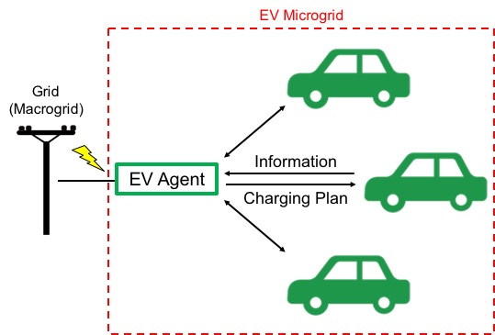

Figure 1: Schematic diagram of EV agent model

Our model is based on a number of simplifying assumptions:

* All vehicles are the same model and thus have the same technical specifications—for example, battery capacity, fuel economy, and plug-in charging rate. In our study, all vehicles are assumed to be Tesla Model S (2015 85D Option).
* Vehicles only charge at home. Although some vehicles use charging stations in reality, the majority of EVs still charge at home, making this assumption a reasonable abstraction. This assumption leads to the two following assumptions.
* EVs whose traveling distance between their departure from home and return exceeds the driving range of Tesla Model S (approximately 250 miles) are excluded from our analysis because excessively long journeys lead to a negative SOC value.
* Vehicles that do not return home are also excluded from our analysis.
* All vehicles charge with 240V charging cable. (Charging rate: approximately 9.6 KW)[7]
* Since our model analyzes vehicles in one grid system, we choose to examine vehicles in one region, Texas.
* Electricity pricing follows the actual residential electricity prices in El Paso, Texas. The peak hour price, which occurs from 12:00 to 20:00 daily, is 0.15831 USD/KWh; the off-peak price is 0.06743 USD/KWh.[8]
* The driving profiles of vehicles are the same everyday.

In order to understand EVs’ influence on grid robustness, we should first find EVs’ total power consumption from the grid over time. Total power consumption is the sum of individual power consumption. A charging EV—SOC of which is increasing—draws 9.6 KW of power from the grid. Therefore, individual power consumption at time *t* can be defined by a simple piecewise function:

And total power consumption at *t* is defined as follows:

Next, to examine how much cost can be saved by our microgrid, daily total cost should also be calculated.

**4.2 Alternative Charging Plans**

As soon as an EV is parked at home, it informs the EV agent how much time it needs to be fully charged and when its next departure is. EV agent makes one of the two following decisions:

1. (time until next departure) – 60 minutes (time required for charging)

: charge the EV immediately (original charging plan)

1. (time until next departure) – 60 minutes (time required for charging)

: sends back an alternative charging plan

Figure 2 shows the SOC curves with an original charging plan and five alternative charging plans. Alternative plans distribute power consumption by delaying charging or dividing charging into two or three steps. Before and after each charging step, there are pauses of random lengths (marked with “R” in Figure 2), which play a key role in randomly distributing power consumption.

Here, a very simple SOC curve is presented as an example. This sample vehicle is used and thus discharges from 5:00 to 10:00; it starts charging at 10:00 (*thome*); its next scheduled departure is at 20:00 (*tleave*). The curves in Figure 2 confirm that SOC between *thome* and *tleave* changes differently as different alternative charging plans are applied. Table 1 characterizes all charging plans. In Alternative Plans 2 and 4, the first charging step starts immediately; however, the second and third steps are placed randomly.

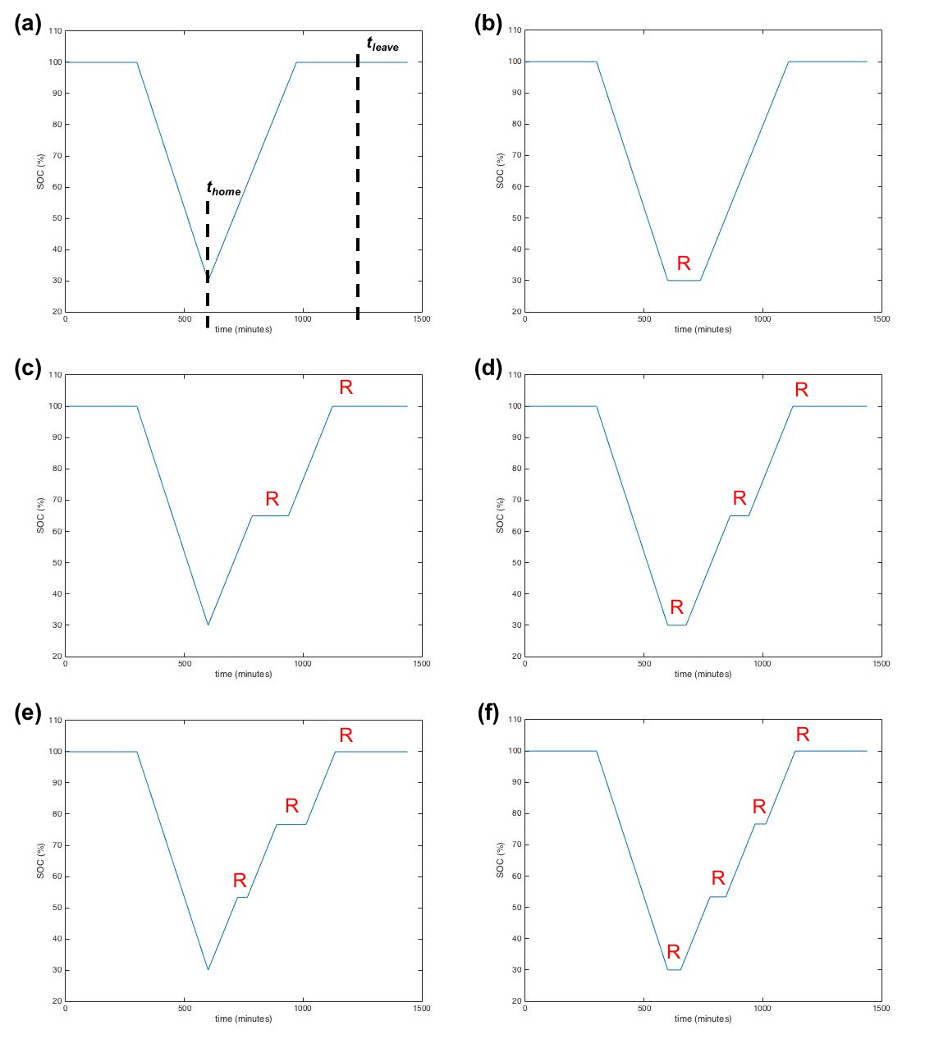

Figure 2: SOC curves with different charging plans

(a) original charging plan, (b)-(f) alternative charging plans 1 through 5

|  |  |  |  |
| --- | --- | --- | --- |
|  | Start | Number of Steps | Figure |
| Original Plan | Immediate | 1 | 2(a) |
| Alternative Plan 1 | Random | 1 | 2(b) |
| Alternative Plan 2 | Immediate | 2 | 2(c) |
| Alternative Plan 3 | Random | 2 | 2(d) |
| Alternative Plan 4 | Immediate | 3 | 2(e) |
| Alternative Plan 5 | Random | 3 | 2(f) |

Table 1: Charging plans

**4.3 EPOS**

EPOS, namely Energy Plan Overlay Self-stabilization system, is a decentralized agent-based optimization engine to coordinate participants’ energy plans with respect to a certain energy utilization objective.[10] In EPOS, an agent is defined as a software agent, which can automatically control the activities of a group of energy exchange devices, and alter its energy utilization based on the communication with other agents. The main mechanism and structure of EPOS are as follows:[11]

1. Organize agent connection based on tree topology

EPOS builds up the agent-network in a tree topology. It automatically assigns each agent to a certain level, on each level several agents belong to an upper parent. In contrast to the conventional centralized optimization, EPOS does optimization in a decentralized bottom-up approach. In other words, each parent can locally coordinate the plan selection with its children and generate their best local aggregate plan to the upper level, till the global optimization complete.

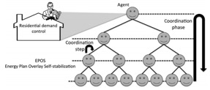

Figure 3: Tree topology used in EPOS

1. Optimize based on exploited alternative plans:

EPOS assumes that every individual software agent can exploit various energy utilization plans in a certain time period, such as the power consumption profile in the next 24 hours. Each agent owns at least one plan and EPOS can only do the optimization by selecting available plans. As each household can define the plan generating strategy of its agent, the preference of each household can be fully respected and guaranteed.

1. Stabilize global energy utilization based on local adaption

To better reach a common goal of global energy utilization, such as the robustness and stability of a grid.

And based on its mechanism, EPOS possesses following advantages:

1. Compatibility with power or Internet infrastructures

Compared to a centralized structure, the tree topology of EPOS is much more similar to the structure of Internet or grids in reality. Therefore, based on this structure, it is more promising to transform this visual engine into real-life application in the future.

1. Quickness in a large-scale optimization

Because the optimization workload can be distributed and localized in a smaller scale, EPOS can reach a much faster optimization speed compare to a centralized engine. It is a very crucial aspect of performance when considering the future size of a micro grid, which may contain thousands of households.

1. Privacy with distributed communication and decision making

As every parent can only “see” the aggregate plans of its closest children, the details of lower level decision process are naturally hidden. Therefore, the data privacy of individual plans can be guaranteed by this restricted data accessibility.

In our microgrid model, EPOS serve as a global optimization engine in our EV micro grid model. Based on our assumption and restriction of the charging patterns of electric vehicle, various daily alternative plans (charging kW in each minute) are generated. In order to functionalize EPOS in our model, the following works are needed:

1. Exploit alternative energy plans of each agent
2. Converse plan dataset into EPOS “.plan” input file
3. Design experiment, specifying variables and parameters

After running EPOS, we obtain and interpret its results.

**5 Implementation**

**5.1 Overview**

(To be added later)

**5.2 Driving Profile Generation with NHTS Travel Data**

The charging behaviors of batteries in electric vehicles depends on the driving profiles of these EVs, which determines how much energy is consumed by the vehicles and when the batteries are available to be charged. In our study, a set of driving profiles is constructed using data from the 2009 National Household Travel Survey (NHTS).[12] One single driving profile for each vehicle consists of two parts, *i.e.*, its traveling speed and location throughout a day, which are derived using two functions, *‘FUNC_speed.m’* and *‘FUNC_location.m’,* respectively.

**5.2.1 Extracting Data from NHTS Database**

The NHTS is conducted by the Federal Highway Administration of United States by interviewing persons in 70,000 households in US about their travelling behaviors in certain days. The results are organized into four different data files, among which the day trip file containing “data about each trip the person made on the households randomly assigned travel day” is applicable for our research.[13] We take 6 variables that are applicable for our research from the total over one hundred ones in the NHTS’s day trip file. The names and the explanations as well as the meanings of the values of the variables are listed in Table 2.[14]

|  |  |  |
| --- | --- | --- |
| Name | Explanation | Values ranges and their meanings |
| HOUSEID | HH eight-digit ID number |  |
| PERSONID | Person ID number |  |
| ENDTIME | Trip END time in military | 0000-2359, corresponding to time in a day 00:00-23:59 |
| TRVL_MIN | Trip time - minutes | 0-1230 |
| WHYTO | Travel day purpose of trip | 1. Home   10-14 Work related  20-24 School related  30- Medical/dental services  40-43 Shopping related  50-55 Social related  60-65 Family related  other: other reasons |
| TRPMILES | Calculated Trip distance converted into miles | 0-9000 |

Table 2. Variables selected in the datasets

Considering the size of data profiles and the physical scale of a power grid,

Only households in Texas state are included in our data sets.

The data is selected and imported into MATLAB using the command lines in *‘gen_Matlab_data.m’*.

**5.2.2 Generating Speed Profile of EVs**

The speed profile of a EV gives information about the speed of the given EV at each time point in the day. This information is necessary when we attempt to obtain the discharging rate and energy consumption of the batteries. To derive these speed profiles, we construct the *‘FUNC_speed.m’* function.

The time step is 1 minute in our study, which is corresponded in other functions. We firstly generate a subtable containing 'ENDTIME', 'TRVL_MIN' and 'TRPMILES' of trips conducted by the first person in the given HOUSEID.

% Select the row for a given houseid

% Only select the first member of the household whose PERSONID == 1

rows = table.HOUSEID==oused & table.PERSONID==1;

subtable= table(rows, {‘ENDTIME’, ‘TRVL_MIN’, ‘TRPMILES’});

Figure 4: Implementation to make a subtable with households’ first individuals

Only one person is taken into consideration because, in case two or more household members move in one vehicle, multiple journeys are recorded in our dataset although they may be actually one trip from the vehicle’s perspective. Each row of the subtable represents a single trip. We define the speed during the travel period as constant and thus can be calculated as:

The travel distance and time are directly obtained from variable 'TRPMILES' and 'TRVL_MIN', while the travel period shall be derived by taking (ENDTIME) – (TRVL_MIN) as starting point and (ENDTIME) as end point. It is noticeable that 'ENDTIME'-'TRVL_MIN' as starting point might go zero or negative sometimes which means the trip started before midnight. In these cases, we just define start point to be 1 as our time scope is only one day from 1 to 1440 minutes. These implementations are realized as in Figure 5.

for i=1:height(subtable)

t_start=subtable.ENDTIME(i)- subtable.TRVL_MIN(i);

if t_start<1

t_start=1;

end

t_range= t_start:(subtable.ENDTIME(i) - 1);

speed(t_range)= subtable.TRPMILES(i)/subtable.TRVL_MIN(i);

end

Figure 5: Implementation to set up starting and end points of a journey

The final output of this function is a one-demission vector where each element is the speed value at each minute in the day and the index of elements is corresponding to the time with minute as the unit.

**5.2.3 Generating Location Profile of EVs**

The location profile of a EV shows where the EV is during a day. Three values are to be assigned at each time point, which are respectively representing: ‘1’ as “at home”, ‘-1’ as “on road”, ‘0’as “at other places”. These definitions are determined corresponding to the state of charging of the batteries, *i.e.,* batteries are available to be charged at home (represented as ‘1’), and are discharged on road (represented as ‘-1’) while they would not be charged or discharged so stay constant at other places (represented as ‘0’). The *‘FUNC_location.m’* function is constructed to get the location profiles.

Similar to the process of speed function, we create a subtable containing 'ENDTIME', 'TRVL_MIN', 'TRPMILES' and a new variable ‘WHYTO’ of trips of the given person.

%Selcet data for the given houseid

%only select the first person, which means PERSONID=1

rows = table.HOUSEID==houseid & table.PERSONID==1;

subtable= table(rows, {'ENDTIME','AWAYHOME', 'TRVL_MIN', 'WHYTO' });

Figure 6:

For each trip, we first nominate the period of time when the trip is being taken place, *i.e.,* the vehicle is on road. We define the location value during these period is ‘-1’ as explained previously. Since we have the information of ‘WHYTO’, we know the location of the vehicle after this trip. Therefore, from the next minute after the trip to the last minute before next trip (or the last minute of the day), we can assign value to the location according to the value of ‘WHYTO’, which is achieved as following:

period= subtable.ENDTIME(i)- subtable.TRVL_MIN(i): subtable.ENDTIME(i)-1;

for t=period(period>0)

location(t)=-1;

end

% consider the cases when the vehicle is not moving

% change the location

t=t+1;

if t<1

t=t+1;

end

while (speed(t)==0) && (t<=(60*24-1))

if subtable.WHYTO(i)==1

location(t)=1;

else

location(t)=0;

end

t=t+1;

end

Figure 7:

To point out, such a method does not cope with the location before the first trip, so we initialize the location values as ‘1’, assuming every vehicle stays at home before any trips are conducted.

%Initialization

location=ones(1,60*24);

Figure 8:

The final output of this function is a one-demission vector where each element is the location value at each minute (‘1’- “at home”, ‘-1’- “on road”, ‘0’- “at other places”) in the day and the index of elements is corresponding to the time with minute as the unit.

**5.3 State of Charge (SOC)**

**5.3.1 State of Charge with Regular Charging Plan**

In order to find the total power consumption and electricity cost of the microgrid, we first found the SOCs of each vehicle for a day, from *t* = 0 to *t* = 1440 minutes. Figure 9 illustrates the steps to calculate SOCs with the NHTS travel data.

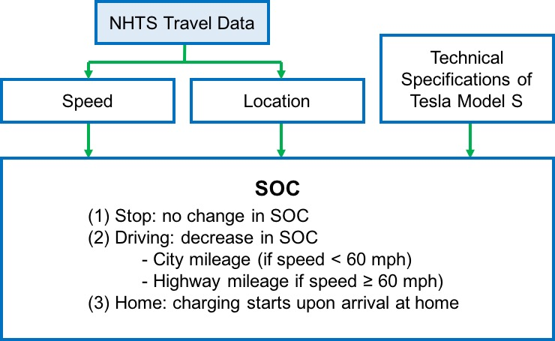

Figure 9: Calculation of SOC

First, the function *FUNC_speed.m* found the speed of each vehicle at *t*. The calculated speed values were later used to determine the power discharge rate of a vehicle at *t*. For example, if the vehicle’s speed is higher than 60 mph at a certain point, the vehicle consumes 0.33 KWh of electricity per mile, which is the highway fuel economy of Tesla Model S. The implementation code is presented in Figure 10.

Next, we executed the function *FUNC_location.m* to find the location of each vehicle at *t*. Since we are assuming that all vehicles charge only at home, we are only interested in if a vehicle is parked at home (charging), parked at other locations (no change), or moving on the road (discharging). Thus, if the WHYTO value at *t* is not equal to 1 (home), the location at that time is defined to be 0 (other locations). The implementation code is shown in Figure 11.

In order to calculate the SOC at *t*, we referred to the technical specifications of Tesla Model S. The values that were used in our simulation include *Battery Capacity* = 85 KWh, *Charging Rate* = 9.6 KW, *City Fuel Economy* = 3.00 mi/KWh, *Highway Fuel Economy* = 3.03 mi/KWh.[7]

% select the row for a given HOUSEID

% only select the first member of a household (PERSONID == 1)

rows = table.HOUSEID==houseid & table.PERSONID==1;

% create speed profile

for i=1:height(subtable)

t_start=subtable.ENDTIME(i)- subtable.TRVL_MIN(i);

if t_start<1

t_start=1;

end

t_range= t_start:(subtable.ENDTIME(i) - 1);

speed(t_range)= subtable.TRPMILES(i)/subtable.TRVL_MIN(i);

end

Figure 10: Implementation to find the speed of every vehicle at *t*

for i=1:height(subtable)

if (subtable.ENDTIME(i)- subtable.TRVL_MIN(i))>0 && subtable.TRVL_MIN(i)>0

period= subtable.ENDTIME(i)- subtable.TRVL_MIN(i): subtable.ENDTIME(i)-1;

% vehicle is on the road

for t=period(period>0)

location(t)=-1;

end

% consider the case when the vehicle is not moving

% set location = 1 (home) or 0 (other locations)

t=t+1;

if t<1

t=t+1;

end

end

Figure 11: Implementation to find the location of every vehicle at *t*

With the calculated speed and location values from t = 0 to t = 1440 and the battery specifications of Tesla Model S, *FUNC_SOC.m* finds the SOC curve of each vehicle. As described in Figure 9, if a vehicle stops at a location other than home, there is no change in SOC. If a vehicle is on the road, the discharging rate is determined by the speed of the vehicle. Battery charging starts as soon as a vehicle arrives at home—at time *t* when the car’s *location* value first changes to 1.

Figure 12 shows the SOC curve of a sample vehicle (HOUSEID = 32957150). The flat line segment marked in blue indicates that the vehicle is parked somewhere other than home during the time period. The upward curve, marked in red, represents the charging of the vehicle, which starts as soon as it comes back home.

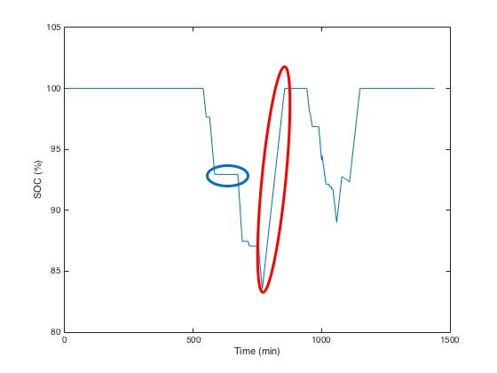

Figure 12: Sample SOC Curve

After SOCs of all vehicles are found, the vehicles whose SOC goes below 0 at any point in time are excluded from our analysis. Since our model does not consider the possibility of recharging electric vehicles at charging stations, the SOC vector of a vehicle that travels further than approximately 250 miles—the driving range of Tesla Model S—without coming home includes negative numbers. We converted the SOC vectors of such vehicles into NaN’s, as shown in Figure 13.

% Convert SOC vectors with negative elements into NaN’s

if any(SOC<0)

SOC=NaN;

end

Figure 13: Implementation to delete vehicles with negative SOC elements

**5.3.2 State of Charge with Alternative Charging Plans**

After each vehicle’s regular SOC vector was determined, we found the SOC vectors when alternative charging plans were applied. As illustrated in Figure 2 in Section 4.2, the most notable feature in the alternative plans is that there are pauses of random lengths before and after charging steps. For example, Figure 2(f) shows that there are 4 pauses in the Alternative Plan 5. Once the total amount of time available for pauses is determined, the length of each pause is determined relatively. The implementation code is available in Figure 14.

If an alternative charging plan is applied, a new 1×1440 SOC vector is generated as an output. In the new alternative SOC vector, the elements in the time interval between *thome* and *tleave* are replaced. If a vehicle leaves and comes home multiple times, there can be more than one time intervals in which the SOC values are replaced.

% pauseTotal is the sum of all pauses between charging steps [in minutes]

pauseTotal = t_leave - t_home - t_charge - 60;

% In this alternative plan, there will be four pauses

R = rand(1,4);

pause1 = round((R(1)/sum(R))*pauseTotal);

pause2 = round((R(2)/sum(R))*pauseTotal);

pause3 = round((R(3)/sum(R))*pauseTotal);

pause4 = round((R(4)/sum(R))*pauseTotal);

Figure 14: Implementation to randomly determine the lengths of pauses

**5.4 Power Consumption**

To analyze the effect of the EV microgrid on grid robustness, the total power consumption from the grid should be calculated. Charging a Tesla Model S vehicle consumes 9.6 KW of power from the grid. With SOC vectors, the daily total electricity consumption of all vehicles in the microgrid can be calculated by a simple relation.

if SOC(t)-SOC(t-1)>0

electricity(t)=car.ChargeKW

end

Figure 15: Implementation to calculate power consumption at *t*

As seen here, if a vehicle’s SOC is increasing at a certain time, it must be charging and its power consumption rate at the given moment is 9.6 KW.

**5.5 EPOS**

In order to optimize global energy consumption by using EPOS engine, the conversion of the alternative plans into EPOS standard readable format becomes necessary.

As mentioned in the report above, the input data of each household should be several 1440 long vectors, where each vector represents the minute wise energy consumption of the alternative plan.

And also, EPOS can select plans based on the relative significance, which can be reflected by a weight scalar. Here, we set weight = 1.0 for every plans, assuming that every household have same preference on their plans. Therefore, the final input data (.plan file) should be formatted as:

XXXX-XX-XX.plan (Usually can be a representative date)

1.0: 0, 0, 0, 9.6, …… (weight=1.0, followed by 1440 numbers, separated by comma, in kW/h)

1.0: 0, 9.6, 9.6, 0, ……

Etc.

The detailed steps are follows:

1. Construct EV pools and generate SOC profile

In order to better explain the effect of EV numbers and alternative plans patterns (schemes), other irrelevant variables, such as regions, day of travel, should be controlled.

In a single experiment, only households in the same state, such as Texas, are considered, based on assumption that the households in the same state are able to build up an EV neighborhood and share the same electricity price. Further, being aware that households usually have different driving patterns between weekdays and weekends, we only use the driving profile collected on weekdays.

Therefore, the implementation should be :

load TexasTable % loading data of Texas from NHTS

load CarModel

row= (table.TRAVDAY<=5); % only consider weekdays

subtable=table(row,:);

HHpool = unique(subtable(:,{'HOUSEID'})); % construct household pools

1. Detection and Exclusion of non-valid EVs

Some EV may have NaN’s as their SOC file (because of the negative values when generating SOC profile, see section 5.2). Also, some EV may be totally inactive during the day, which means SOC always remains 100% and has no interaction with the grid. These two kinds of EVs should both be excluded in our experiment.

count =1;

while count<=EV_number

SOCori=FUNC_SOC(subtable,HHpool.HOUSEID(i),model(car_index,:));

if isnan(SOCori(1,1))==0 && range(SOCori)~=0

………%(codes for generating .plan file)

count = count+1;

end

1. Obtain alternative plans

if count<=plannedEV_number

altMatrix=FUN_SOCalter(SOCori,FUNC_location(table,HHpool.HOUSEID(i)),model(car_index,:),pattern);

else

altMatrix=SOCori;

end

1. Generate EPOS readable “.plan” file

The .plans

for j=1:length(altMatrix(:,1))

fileID = fopen(filename,'a');

fprintf(fileID,'1.0:');

fclose(fileID);

dlmwrite(filename,FUNC_electricity(altMatrix(j,:),model(car_index,:)),'-append','delimiter',',')

end

1. Generate auxiliary file, such as price signal

The price signal is a text file with 1440 lines, one price scalar on each line. Here we use the electricity price of EL PASO Electric Company in Texas.[8]

On Peak: 0.15831 USD/kWh

Off Peak: 0.06743 USD/kWh

Where the on peak hours are define as 12:00-20:00

1. Run experiments on EPOS

The experiments are designed as follows.

|  |  |  |  |  |  |  |  |
| --- | --- | --- | --- | --- | --- | --- | --- |
| foldername | num_EV | num_plannedEV | Scheme | Car  Model | State | optimization goal | |
| 151130_1k_1k_0111 | 1000 | 1000 | [0,1,1,1] | Tesla | TX | robustness |  |
| 151130_1k_1k_0444 | 1000 | 1000 | [0,4,4,4] | Tesla | TX | robustness |  |
| 151130_1k_1k_0777 | 1000 | 1000 | [0,7,7,7] | Tesla | TX | robustness |  |
| 151130_1k_1k_0147 | 1000 | 1000 | [0,1,4,7] | Tesla | TX | robustness | Global cost minimization |
| 151130_1k_50_0147 | 1000 | 50 | [0,1,4,7] | Tesla | TX | robustness | Global cost minimization |
| 151130_1k_100_0147 | 1000 | 100 | [0,1,4,7] | Tesla | TX | robustness | Global cost minimization |
| 151130_1k_300_0147 | 1000 | 300 | [0,1,4,7] | Tesla | TX | robustness | Global cost minimization |
| 151130_1k_500_0147 | 1000 | 500 | [0,1,4,7] | Tesla | TX | robustness | Global cost minimization |

num_EV: The total number of EV, reflects the scale of a certain EV neighborhood. num_plannedEV: The number of households who are willing to alter their EV charging profile and have alternative plans, reflects the collaboration and flexibility of the EV neighborhood.

Scheme: How is the alternative plan generated. 0 means using original SOC (charge as arriving home), 1, 4, 7 means the different charging strategy.

Car model:

Optimization goal: robustness means to minimize the average deviation, Global cost minimization means to minimized total cost based on the on/off peak price.

**6 Results and Discussion**

**7 Summary and Outlook**

**8 Acknowledgements**

**9 References**

[1] Alt, Lowell (2006). [*Energy Utility Rate Setting*](http://books.google.com.au/books?id=RW3tycY4TToC). Lulu.com. p. 66. [ISBN](https://en.wikipedia.org/wiki/International_Standard_Book_Number) [1411689593](https://en.wikipedia.org/wiki/Special:BookSources/1411689593). Retrieved 25 June 2013.

[2] Peterson et al., The economics of using plug-in hybrid electric vehicle battery packs for grid storage, Journal of Power Sources, 2010.

[3] Landsberg, Dennis R.; Ronald Stewart (1980). [Improving Energy Efficiency in Buildings: A Management Guide](http://books.google.com.au/books?id=M0EnqtFxW3cC). SUNY Press. p. 456. [ISBN](https://en.wikipedia.org/wiki/International_Standard_Book_Number) [1438409990](https://en.wikipedia.org/wiki/Special:BookSources/1438409990).

[4] Jeff Cobb (2015-09-16). ["One Million Global Plug-In Sales Milestone Reached"](http://www.hybridcars.com/one-million-global-plug-in-sales-milestone-reached/). HybridCars.com. Retrieved 2015-09-16. U.S. cumulative sales since 2008 totaled 363,265 highway legal plug-in electric passenger cars through August 2015.

[5] Kott, A.; Abdelzaher, T. Resiliency and Robustness of Complex Systems and Networks. *Adapt. Dyn. Resilient Syst.* 2014, *67*, 67–86.

[6] M. A. López et al., Optimal Microgrid Operation with Electric Vehicles, 2011 2nd IEEE PES International Conference and Exhibition on Innovative Smart Grid Technologies (ISGT Europe), 2011.

[7] teslamotors.com/models

[8] Schedule No. 1, residential service rate

[9] Pournaras et al., Decentralized Planning of Energy Demand for the Management of Robustness and Discomfort

[10] E. Pournaras, M. Warnier, and F. M. T. Brazier, “Local agent-based self-stabilisation in global resource utilisation,” *Int. J. Auton. Comput.*, vol. 1, no. 4, pp. 350–373, Dec. 2010.

[11] E. Pournaras, “Multi-level reconfigurable self-organization in overlay services,” Ph.D. dissertation, Dept. Multi-actor Syst., Delft Univ. Technol., Delft, The Netherlands, Mar. 2013.

[12] U.S. DoT, National Household Travel Survey, http://nhts.ornl.gov/download .shtml (2009).

[13] U.S. DoT, 2001 National Household Travel Survey: User’s Guide, http:// nhts.ornl.gov/publications.shtml#usersGuide (2009).

[14] U.S. DoT, 2001 National Household Travel Survey: User’s Guide, http:// nhts.ornl.gov/publications.shtml#coodbook (2009).

**10 Appendix**